**USER MANUAL**

**INSPECT 3D**

Version: 2024.6.8.0

CONTENTS

1) OBJECTIVES 3

1.1) HARDWARE 4

1.2) SOFTWARE 4

2) SOFTWARE APPLICATION 5

2.1) LOGIN 5

2.2) DASHBOARD 6

2.3) SETTINGS 7

2.4) USER MANAGEMENT 8

2.5) SKU MANAGEMENT 9

2.6) MARKING ITEMS 11

2.7) CAMERA MANAGEMENT 12

2.8) IMAGE MANAGEMENT 13

2.9) TEACH IMAGE 14

2.10) COMMUNICATIONS 23

2.11) INSPECTION 24

2.12) ALARMS 25

2.13) RESULTS 26

2.14) REPORTS 27

2.15) TCP SERVER 28

2.16) MODBUS TCP 30

2.17) EDIT IMAGE SETTINGS 33

3) MAINTENANCE 34

4) TROUBLESHOOTING 34

# OBJECTIVES

This document describes the procedure on the usage for the Inspect3D Application.

Basic Architecture of the Inspect3D application:



## 

## 1.1) HARDWARE

**MONITOR**:

**Connectivity**: HDMI or DisplayPort

**Aspect Ratio**: 16:9

**Resolution**:

[Full HD (1920x1080) with 100% Display Scaling]

or

[4K (3840x2160) with 200% Display Scaling]

**DESKTOP PC**:

**Processor**: Intel or AMD

**Cores**: Minimum 8 Cores with Minimum 16 Logical Processors

**Generations**: Intel (12th Gen or Above); AMD (Ryzen5 or Above)

**Integrated Graphics**: Intel UHD/XeGraphics or AMD Ryzen with Radeon Graphics

**SSD**: 1TB; **RAM**: 16GB DDR4

**Additional Graphics Card**: NVIDIA RTX3060 or Equivalent

**Ethernet**: Intel Gigabit Ethernet Port (I219-V or Equivalent)

**USB3.0**: Intel USB3.0 xHCI Compliant Host Controller Type-A

## 1.2) SOFTWARE

**OPERATING SYSTEM**:

Windows 10 Pro or Windows 11 Pro; 64-Bit (x64)

**INSPECT3D APPLICATION**:

|  |  |  |
| --- | --- | --- |
| **Sl** | **Package Name** | **Manufacturer** |
| 1 | MVC++ 2008 SP1 Redistributable Package MFC Security Update | Microsoft |
| 2 | VC++ Redistributable Packages for VS2015-2022-x64 | Microsoft |
| 3 | .NET Framework 4.8 for x64 | Microsoft |
| 4 | MachineVisionLibrary for x64 | Supplier-Licensed |
| 5 | Inspect3D Application for x64 | Supplier-Licensed |

Total Size: The full installation would consume around 50.00GB including Operating System in C-Drive when considered for the new PC.

# SOFTWARE APPLICATION

Click on the “Inspect3D” Application Icon located in the Desktop.

Once the Application is opened, then Application will start. The Below Screen will appear for few seconds which will load all the settings required for the application.

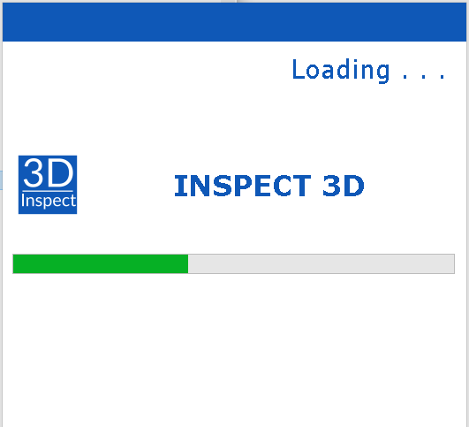

If there are any warnings or error, the respective dialog box will be shown.

After this screen is completed, the Login Screen will open.

## 2.1) LOGIN

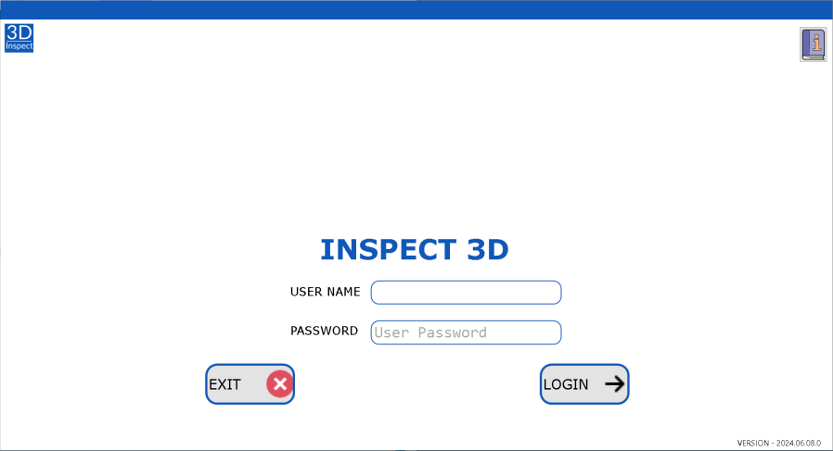

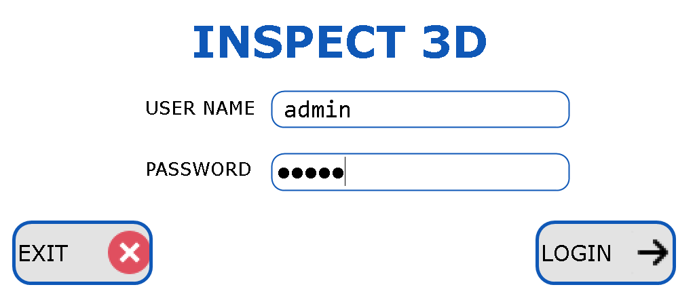

Click on the Icon to open the User Manual

View the Version Number of this Application in the Bottom Right Corner in this Screen.

Enter the Username and Password in the Screen.

Click on Login Button  to Login inside the Application.

Click on Exit Button to Exit the Application.

Check with the Administrator to know the Valid User Name and Password.

The login username will appear on top left corner of every screen.

## 2.2) DASHBOARD

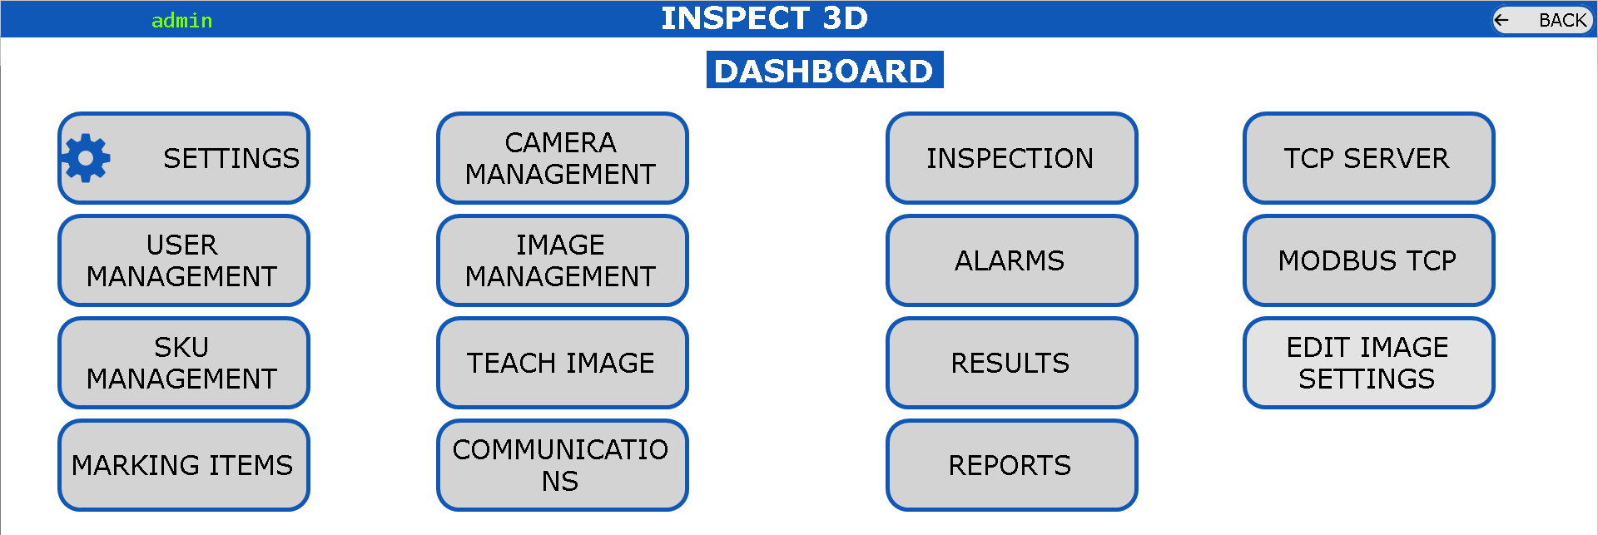

The Dashboard contains all Options available for this Application.

Some of the Options are available based on type of users which is explained in User Management.

**Settings**: All the Settings for the Application are editable.

**User Management**: Add/Delete/View the users for this application.

**SKU Management**: Add/Delete/View the SKUs for this application.

**Marking Items**: Add/Delete/View the Marking Items for each SKU

**Camera Management**: Configure the Camera for each SKU based on the requirement

**Image Management**: Delete/View the Images which are captured as reference by the Camera Management.

**Teach Image**: Edit the Inspection Parameters for each SKU

**Communications**: Add/Delete the Communication Parameters that are required to send out from the Inspection Parameters for each SKU to the other device.

**Inspection**: Inspect the Components based on the configured Settings for each SKU.

**Alarms**: View/Export the Alarms that are logged in this Application.

**Results**: View the Result (PDF, Image, Individual Results) for each inspection Components

**Reports**: View all the Results in a Single View with Statistical Analysis.

**TCPServer**: Sample Application to Test and Check if the TCP Server is working properly with the TCP Client.

**ModbusTCP**: Sample Application to Test and Check if the ModbusTCP is working properly with the TCP Client.

**Edit Image Settings**: Modify the Settings for all Inspection Parameters for PASS/FAIL in single screen.

## 2.3) SETTINGS

Accessible for: Administrator

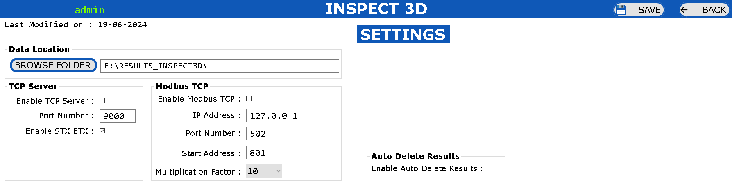

**Data Location**: Click on  Button and Select the Folder where we need to save the Inspection Results.

**TCP Server**: Enter the Credentials of the TCP Server Settings which is used for the Communication to send the data from Application to the other TCPClient Device (PLC, PC, etc.)

**Modbus TCP**: Enter the Credentials of the ModbusTCP Settings which is used for the Communciation to send the data from Application to the other Modbus Device (PLC, PC, etc.)

*Note* : Only 1 Communication Protocol can be enabled, either TCPServer or ModbusTCP.

**Auto Delete Results**: Enable the Checkbox to delete the results automatically during startup of application.

If this option is enabled, then during Startup of the Application, if the Available Space in the “Results Location Drive” is Less than 25% of that respective “Full Drive Capacity”, then the Application will Delete only 1 Inspection Result on the Starting Inspection Date for all available SKUs.

**Save**: Click on Save Button to save the Settings.

**Back**: Click on Back Button to go back to Dashboard Screen.

## 2.4) USER MANAGEMENT

Accessible for: Administrator

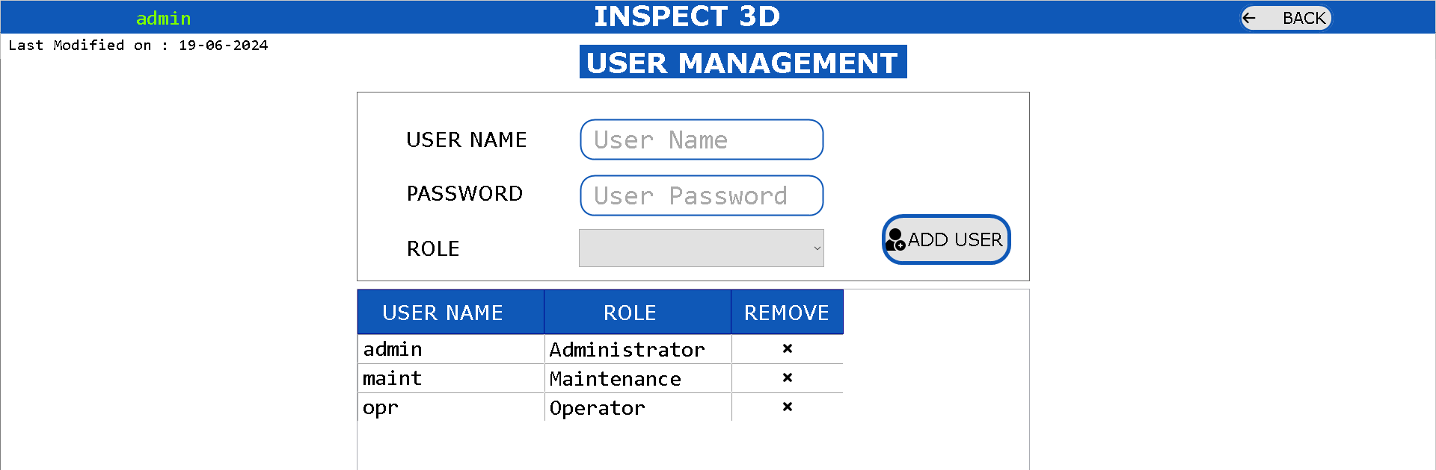

It is possible to “Add new Users”, “Delete Existing Users” and “View Existing Users”.

To Add a New User, Enter the Username (limited to 8 characters) and Password (limited to 8 characters) and Select the Role as “Administrator” or “Maintenance” or “Operator”.

Click on Add User Button .

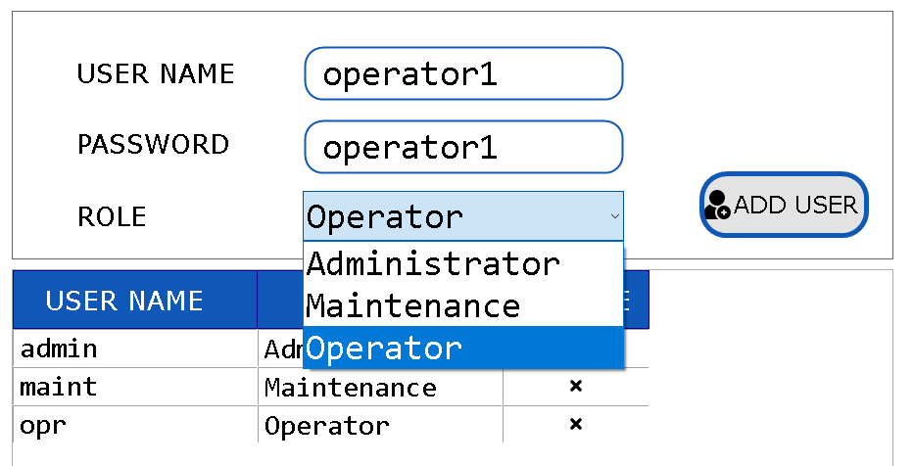

**Role Accessibility:**

|  |  |  |  |
| --- | --- | --- | --- |
| **Option** | **Administrator** | **Maintenance** | **Operator** |
| SETTINGS | YES | NO | NO |
| USER MANAGEMENT | YES | NO | NO |
| SKU MANAGEMENT | YES | NO | NO |
| MARKING ITEMS | YES | NO | NO |
| CAMERA MANAGEMENT | YES | NO | NO |
| IMAGE MANAGEMENT | YES | NO | NO |
| TEACH IMAGE | YES | NO | NO |
| COMMUNICATIONS | YES | NO | NO |
| INSPECTION | YES | YES | YES |
| ALARMS | YES | YES | YES |
| RESULTS | YES | YES | YES |
| REPORTS | YES | YES | YES |
| TCP SERVER | YES | YES | NO |
| MODBUS TCP | YES | YES | NO |
| EDIT IMAGE SETTINGS | YES | YES | NO |

## 2.5) SKU MANAGEMENT

Accessible for: Administrator

It is possible to Create or Delete or Copy or View the SKU.

**SKU ID**: This ID is used as Short-Code for SKU Name to access SKU using PLC, etc.

**SKU Name**: This is used as the name of the Item that has to be inspected.

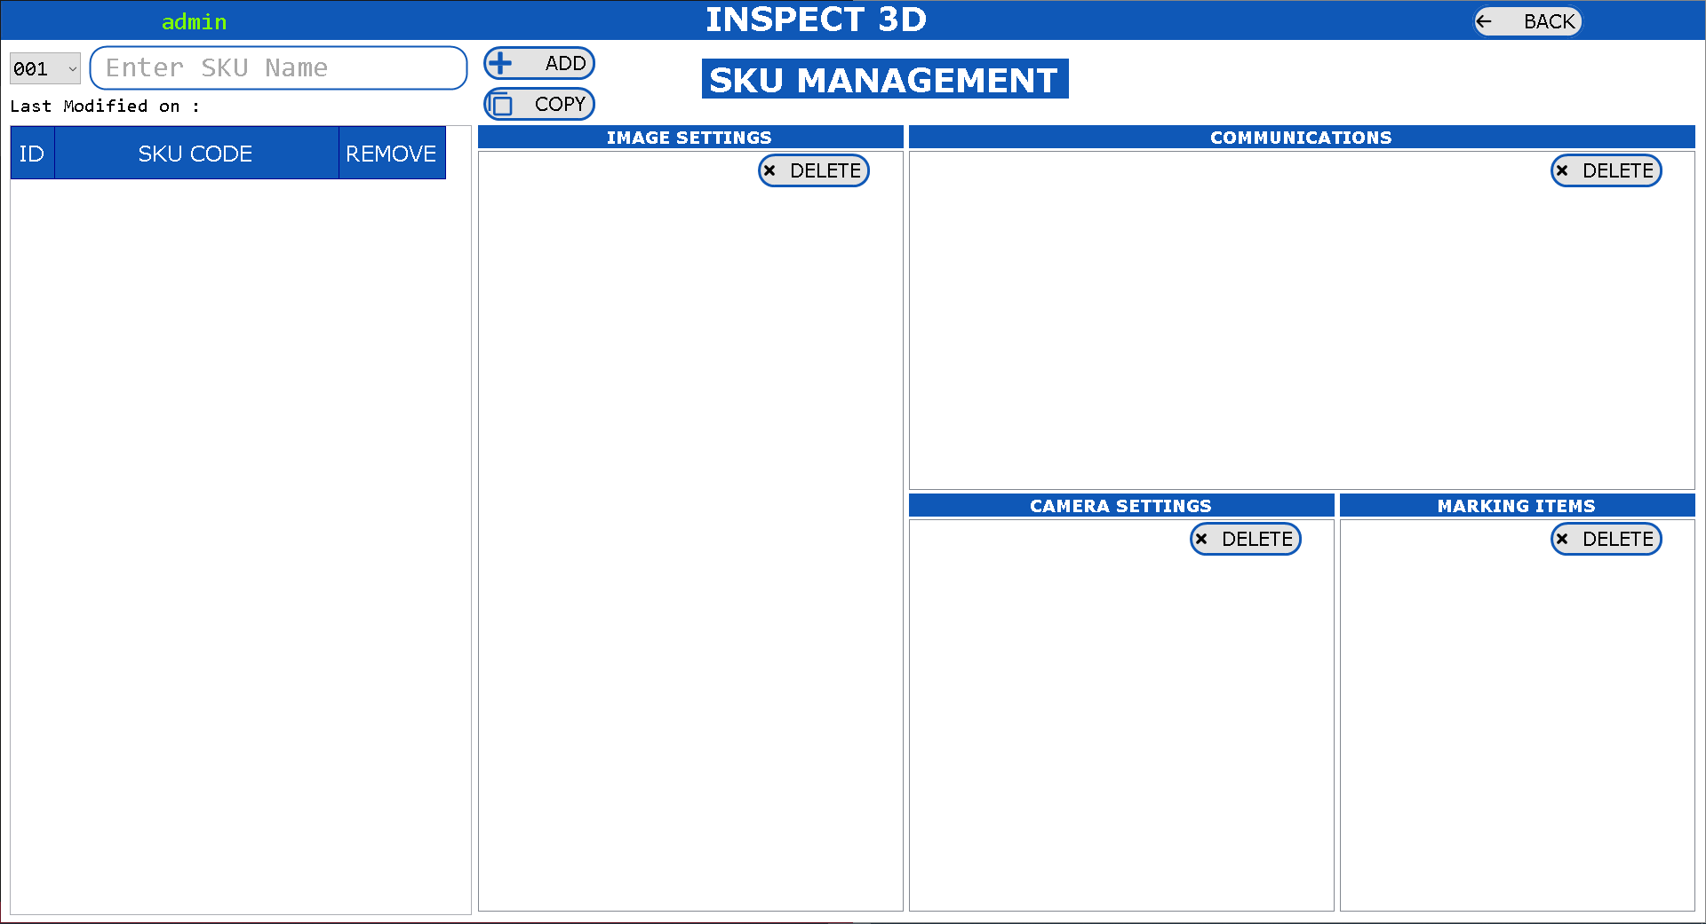

**Create**: Select the SKU ID  and enter the new SKU Name and click on  button. Special Characters and Existing SKU Names are not allowed to create new SKU.

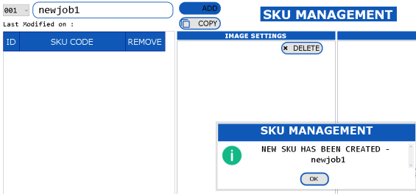

**Delete**: Select the SKU. 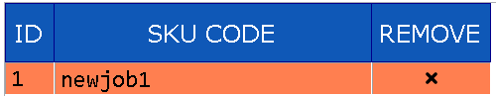 Click on the ‘x’ mark. It will prompt dialog box to accept for the deletion of the SKU. Once it is deleted, it is deleted permanently and it is not possible to recover it back.

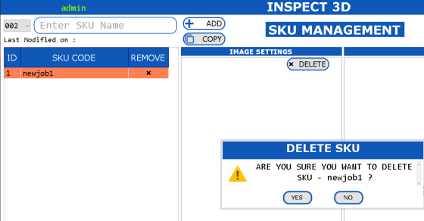

**Copy**: Select the new SKU ID and Enter the New SKU Code. Select the Existing Job and Click on  Button.

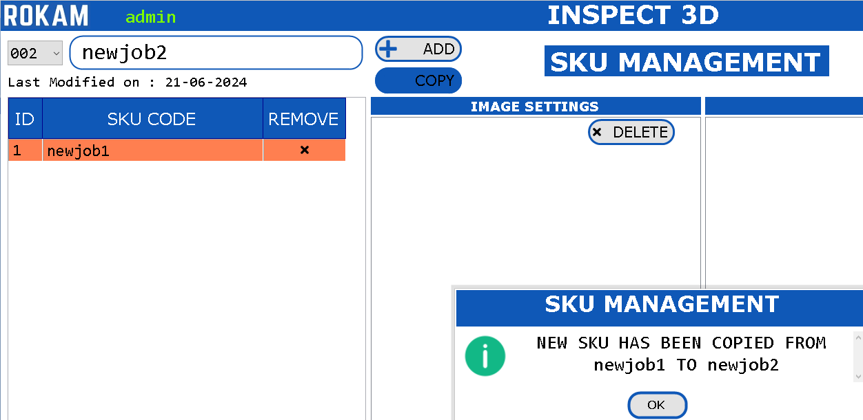

After Copy is completed, the newly copied Job is appeared in the list.

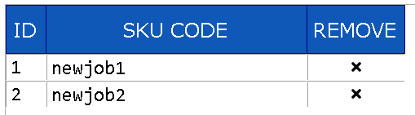

**View**: All the Settings relative for the SKU will be visible in the main screen of this SKU Management.

The Settings that are visible for every SKU are:

* Image Settings: The Inspection Parameters are visible in this section.
* Communications: The values that have to be send to other devices through “Modbus TCP” and “TCP Server” are visible in this section.
* Camera Settings: Each SKU has been configured with the Camera Settings such as Serial Number, IP Address, etc are visible in this section.
* Marking Items: The Inspection Parameters Naming convention which are configured are visible in this section.

It is also possible to delete individual settings by clicking on Button.

## 2.6) MARKING ITEMS

Accessible for: Administrator

There are different tools available in this application for Inspection of component. It is possible to configure the tools which are required for inspection by selecting the Tool Name, Tool ID and Marking Name.

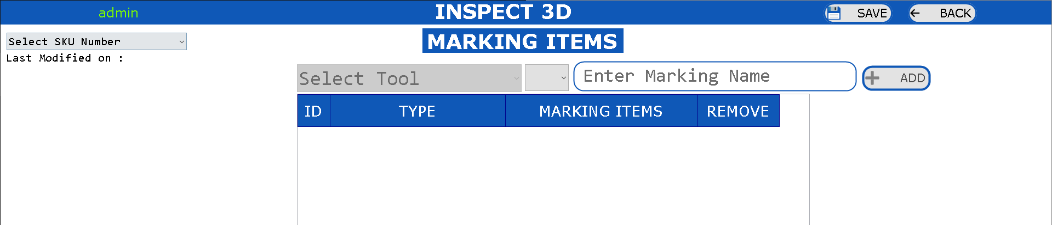

* Select the Existing SKU. 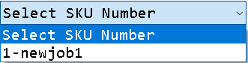
* Select the Tool. 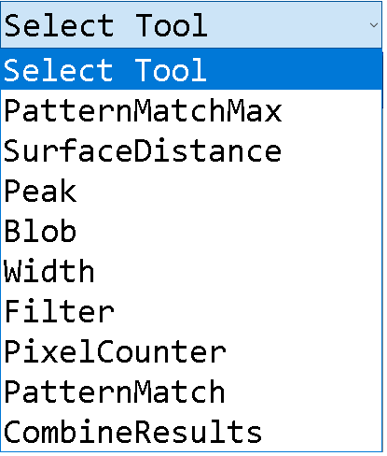 Select Marking ID. 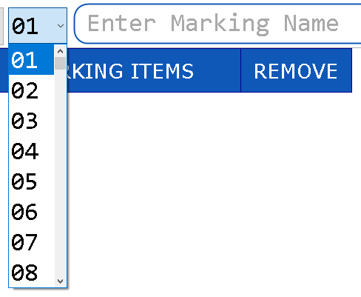
* Enter Marking Name. 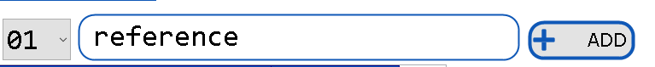and Click on ADD Button.
* Select all inspection parameters and add tools which are required for inspection.
* Click on Save Button to save the inspection parameters linked for the Selected SKU.

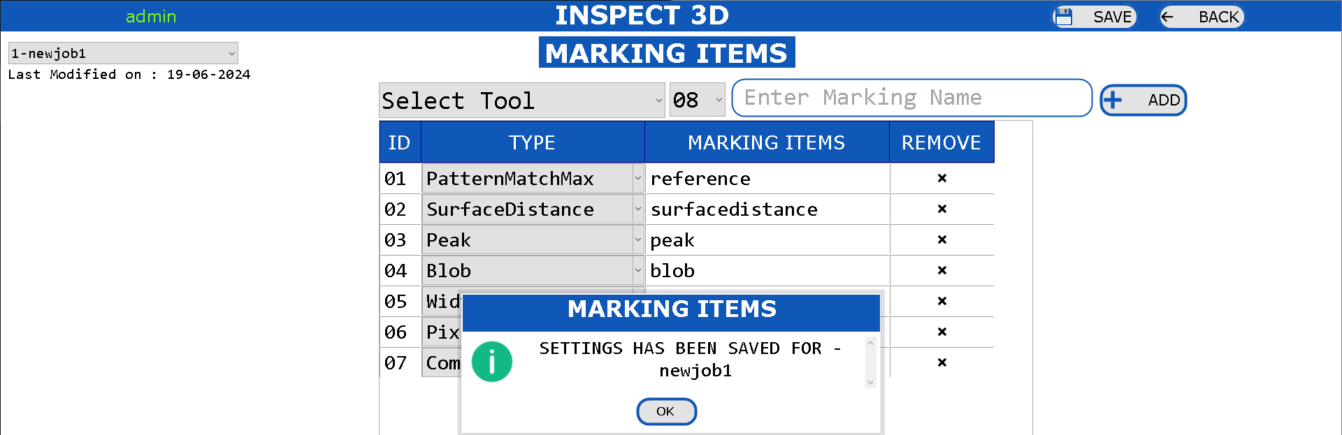

* Click on Back Button to go back to Dashboard Screen.
* Select “PatternMatchMax” as the first marking tool if we need to refer the other inspection tools with pattern match, so that wherever the object moves, the inspection tools will move accordingly.

## 2.7) CAMERA MANAGEMENT

Accessible for: Administrator

It is possible to select the camera from list of available of available cameras configured from the

Each Camera should be selected and configured SKU has to be selected with There are different tools available in this application for Inspection of component. It is possible to configure the tools which are required for inspection by selecting the Tool Name, Tool ID and Marking Name.

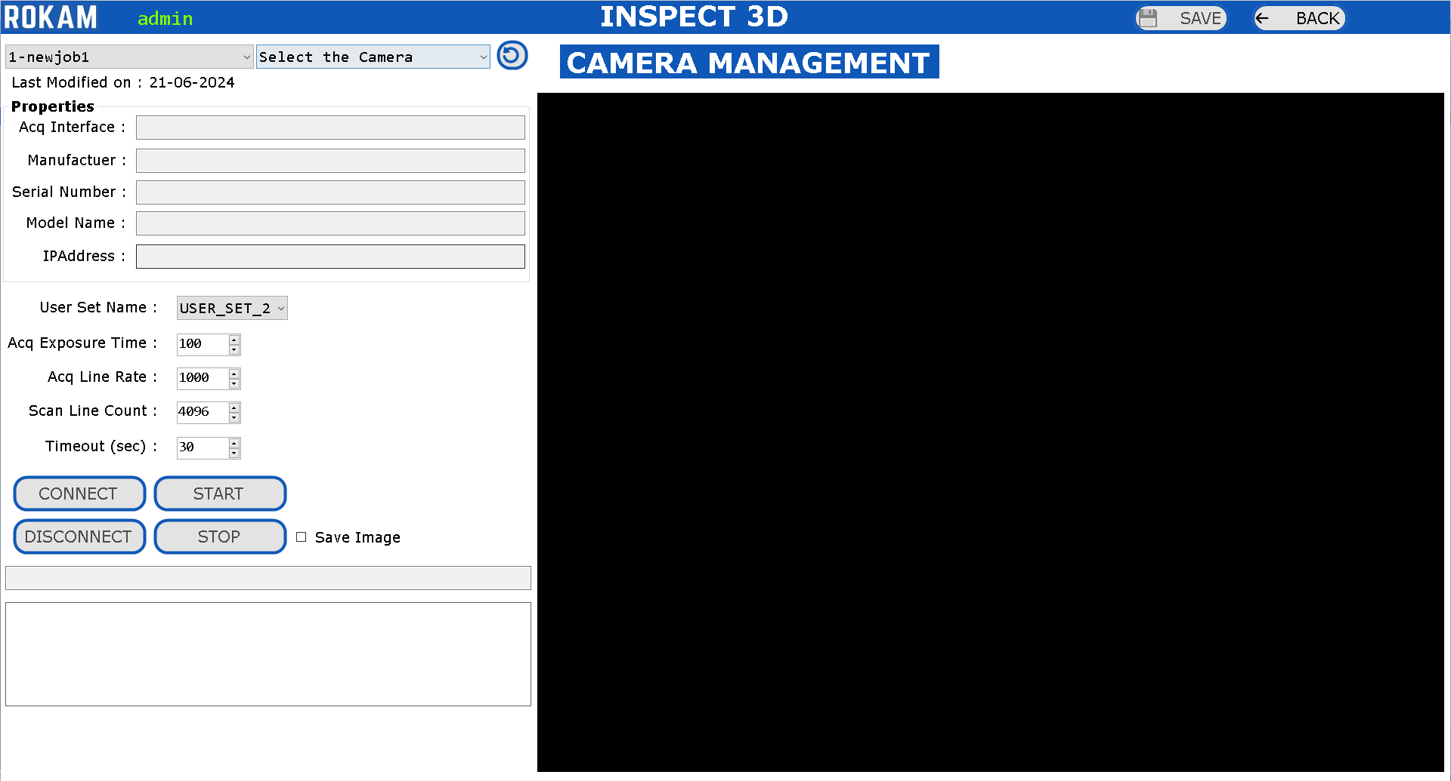

* Select the SKU Number. 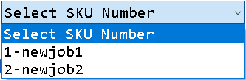
* Select the Camera.
* Enable the Save Image Option. 
* Click on CONNECT Button.
* Click on START Button.
* Send the TRIGGER Command through ModbusTCP from PLC.
* Once the Image is captured, the STOP Button will be clicked automatically.
* Click on  button to save the Camera Settings for the Selected SKU.
* Click on  button to go back to the dashboard.

## 2.8) IMAGE MANAGEMENT

Accessible for: Administrator

The Images which are saved from the “Camera Management” are visible in this screen.

Select the SKU Number

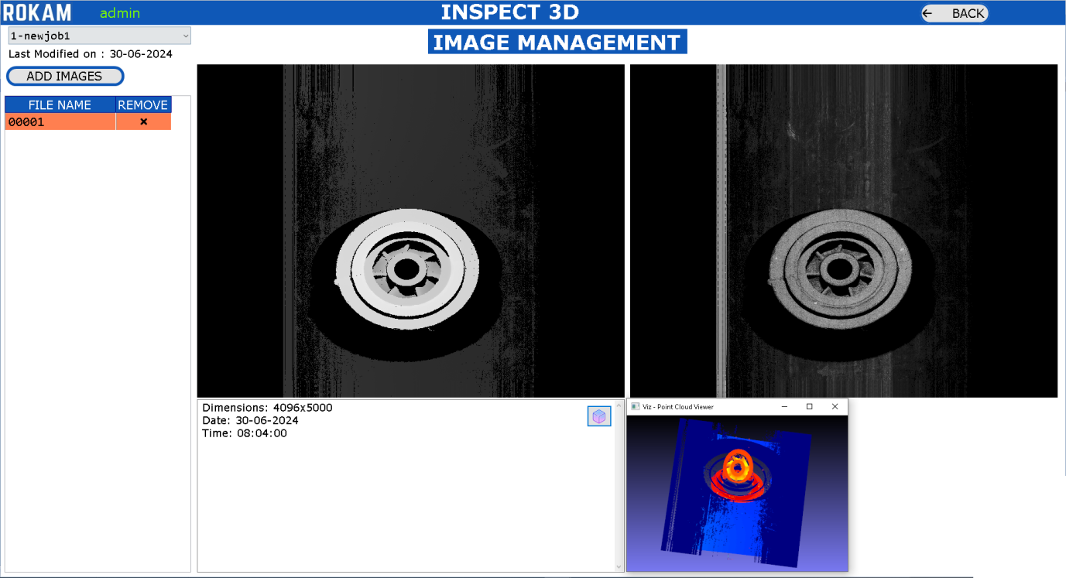

**Add Images**: It is also possible to add images manually, but actually the images should have been captured from the Camera Management. Just in case if we don’t have the camera, it is possible to do an offline inspection by adding the images manually.

**Delete Images**: If the saved images from the camera are not good, then it is possible to delete the image for the selected SKU.

**View Images**: In-order to view the image, click on the file name, then we can see the left-side window with an 3D Image and right-side window with an 2D Image.

Click on 3D Button  to view the image in 3D Viewer.

Click on Button to go back to Dashboard Screen.

## 2.9) TEACH IMAGE

Accessible for: Administrator

Select SKU Number.  Click on  Button

Select Image Number. 

Select Marking Item.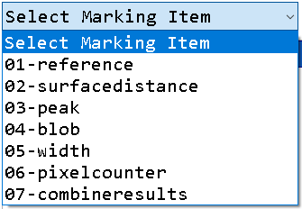

Click on  Button to Add/Edit Inspection Parameters

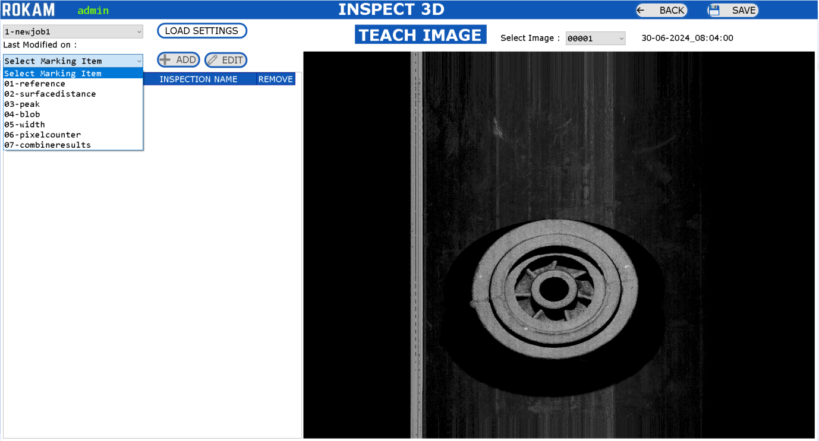

Select any Marking Item and click on  Button.

If the Marking Item is already available in the list, then it is possible to **Delete** the Marking Item by clicking on ‘**x**’ for selected Marking Item, or **Edit** the Marking Item by selecting the Marking Item from list and click on  Button.

Click on  button to save the settings for the Selected SKU.

Click on  button to go back to the dashboard.

When Clicked on ADD/EDIT button, the new screen will open to configure the inspection settings for that respective Marking Item configured Tool Name.

Just for example, for each tool, a new marking item has been added in this user manual. Below is the Description for each Inspection Tool.

**Tools**:

**Pattern Match Max**: This tool is used to identify the pattern which is trained on the image. Used inLocating the Object, Presence/Absence of Objects in Image

**Surface Distance**: This tool is used to measure distance from one surface to another surface for the defined regions.

**Peak**: This tool is used to measure the distance value for the defined region.

**Blob**: This tool is used to count the objects which are available at different surface distances.

**Width**: This tool is used to measure the width between two edges for the defined region

**Pixel Counter**: This tool is used to calculate the number of pixel values available in the given grey scale min-max values. Used for Presence/Absence of Objects in Image.

**Combine Results**: This tool is used to give the combined results of all the configured tools.

After configuring all tools, the teach image screen will look like this:

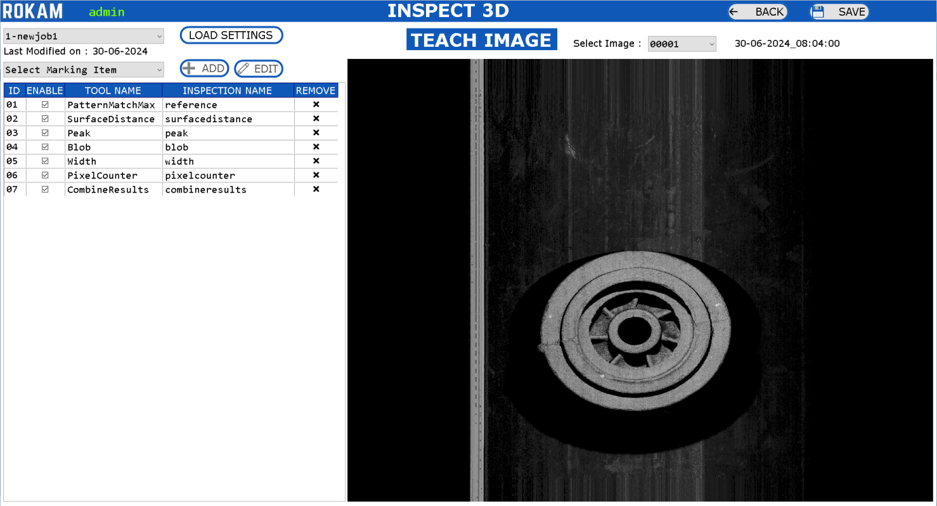

**PATTERN MATCH MAX**

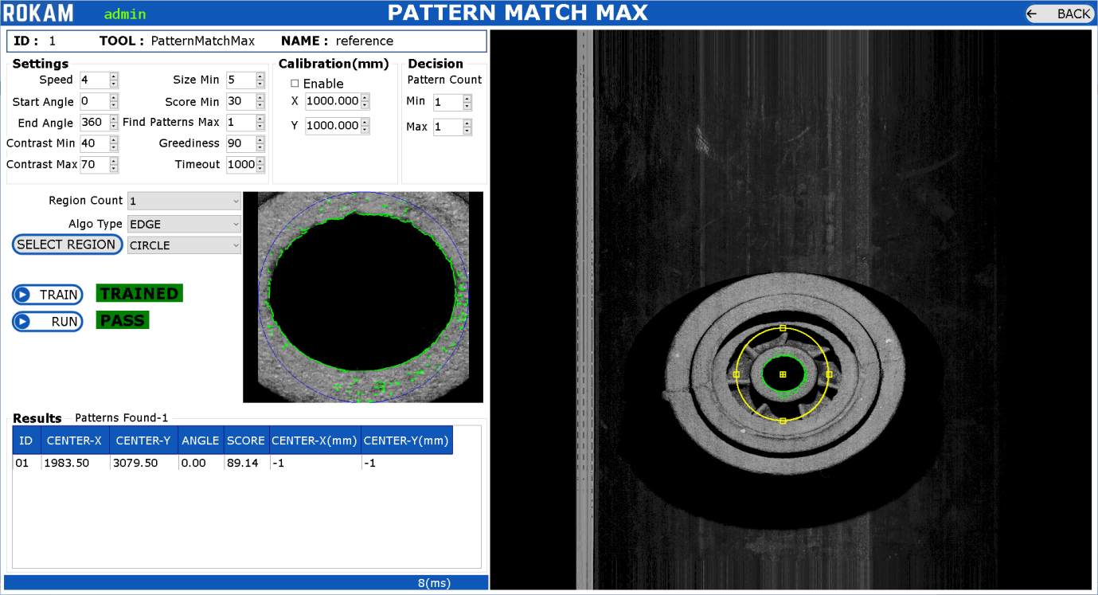

**Search Region**: It is Yellow-Color Region where the pattern has to be searched.

**Pattern Region**: It is Blue-Color Region where the pattern has to be trained.

If the Tool is Added for the First Time, then follow the below procedure:

* Click on Button. Modify the Region of Pattern Region to train the pattern and modify the Region of Search Region in-order to search the Pattern.
* Click on  Button to train the selected PatternRegion.
* Click on  Button to run the Pattern in the Search Region.
* View the Pattern Found Results.
* Click on  Button to go back to Dashboard.

If the Tool is Already Added and Clicked on Edit Button, then follow the below procedure:

* Modify the Search Region (if required).
* Click on  Button to run the Pattern in the Search Region.
* View the Pattern Found Results.
* Click on  Button to go back to Dashboard.

Additionally, there are many settings for the “PatternMatchMax” Tool.

**Result**: The Result will be PASS or FAIL based on conditions, i.e., Pattern Count Min and Max. The Results contains the details such as Center-X, Center-Y, Angle, Score of the pattern.

The Settings depends on type of application on how pattern has to be trained and searched in the image.

**SURFACE DISTANCE**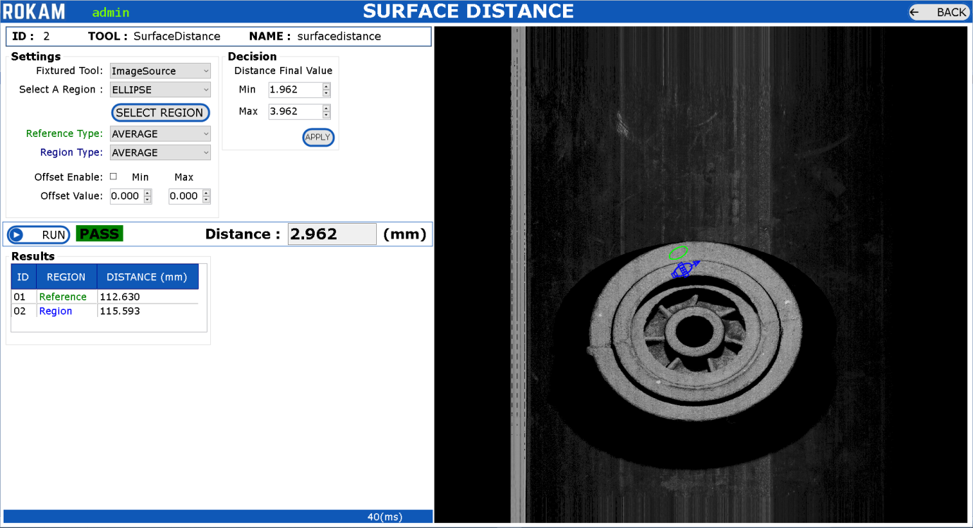

* Click on  Button. Modify the Regions.
* Edit the Min and Max Values for the “Distance Final Value” Decision.
* Click on  Button to get the Results.
* View the Results – the Distance in **mm** between Two Regions.
* Click on  Button to go back to Dashboard.

**Fixtured Tool**: Select ‘ImageSource’ or ’01-reference’ based on requirements.

ImageSource : Load actual image which is captured from camera.

01-reference : Load referenced image which is routed through pattern match max tool. If the Object is moved, then this tool also will move accordingly(x, y, angle).

**Select A Region**: Select the Region as RECT_ROTATED or ELLIPSE**.**

**Select Region Button**: Click on this button to add the new Regions on the image and modify the regions where we need to measure the distance.

**Reference Type**: Select ‘AVERAGE’ or ‘HIGHEST’ or ‘LOWEST’ based on type of measurement which is relevant for Green-Color Region.

**Region Type**: Select ‘AVERAGE’ or ‘HIGHEST’ or ‘LOWEST’ based on type of measurement which is relevant for Blue-Color Region where we need to calculate the distance w.r.t reference.

**Offset**: Enable offset and enter the Min and Max Offset Values – if it is enabled, then the measurement will be measured in between the offset values (mm) only.

**Result**: The Result is PASS or FAIL based on conditions, i.e., Distance Final Value Min and Max. The Results contains details such as Distance in mm between selected two regions.

The Settings depends on type of application on how measurement has to be done between two regions.

**PEAK**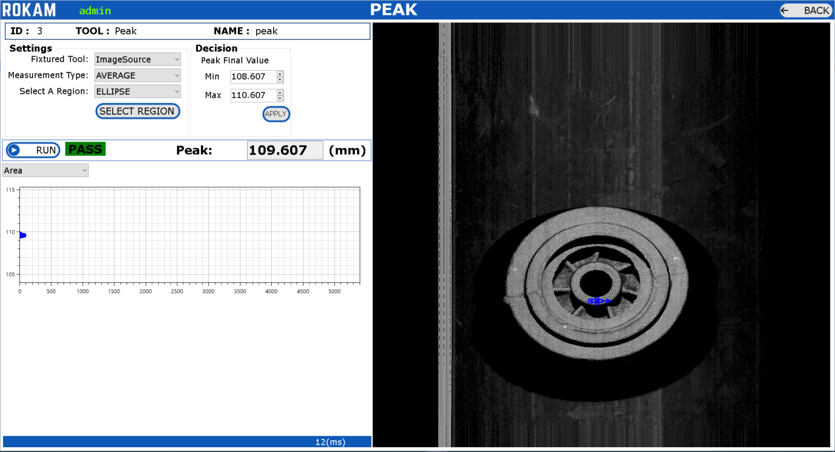

* Click on  Button. Modify the Regions.
* Edit the Min and Max Values for the “Peak Final Value” Decision.
* Click on  Button to get the Results.
* View the Results – the Distance in **mm** at the selected region.
* Click on  Button to go back to Dashboard.

**Fixtured Tool**: Select ‘ImageSource’ or ’01-reference’ based on requirements.

ImageSource : Load actual image which is captured from camera.

01-reference : Load referenced image which is routed through pattern match max tool. If the Object is moved, then this tool also will move accordingly(x, y, angle).

**Measurement Type**:Select ‘AVERAGE’ or ‘HIGHEST’ or ‘LOWEST’ based on type of measurement.

**Select A Region**: Select the Region as RECT_ROTATED or ELLIPSE**.**

**Select Region Button**: Click on this button to add the new Region on the image and modify the region where we need to measure the peak value.

**Result**: The Result will be PASS or FAIL based on conditions, i.e., Peak Final Value Min and Max. The Results contains the details such as Peak in mm.

The Settings depends on type of application on the peak value has to be measured.

**BLOB**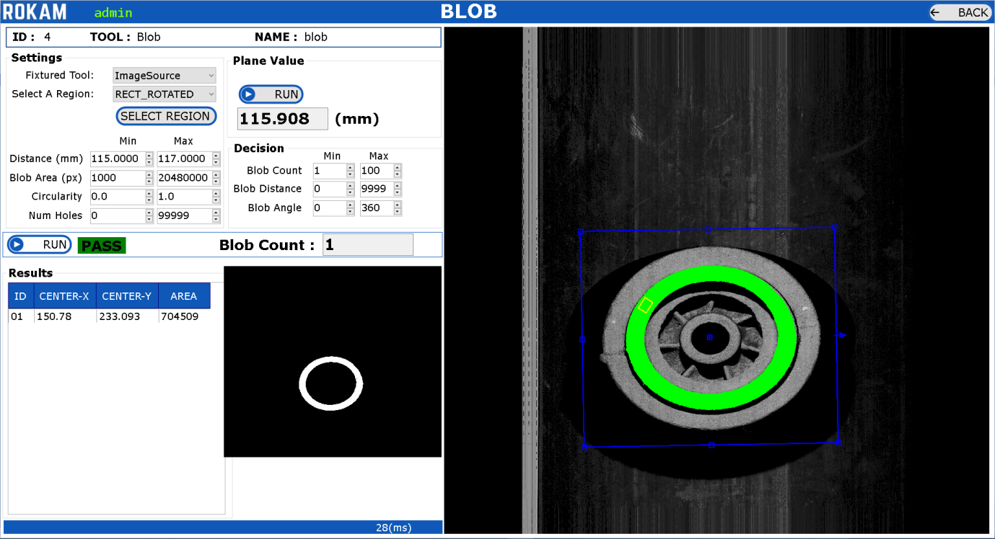

* Click on  Button. Modify the Regions.
* Enter the Distance Min and Max Values.
* Enter the Blob Count Min and Max Values.
* Click on  Button to get the Results.
* View the Results – (Center-X, Center-Y in mm) and Blob Area at the selected region.
* Click on  Button to go back to Dashboard.

**Fixtured Tool**: Select ‘ImageSource’ or ’01-reference’ based on requirements.

ImageSource : Load actual image which is captured from camera.

01-reference : Load referenced image which is routed through pattern match max tool. If the Object is moved, then this tool also will move accordingly(x, y, angle).

**Select A Region**: Select the Region as RECT_ROTATED or ELLIPSE**.**

**Select Region Button**: Click on this button to add the new Region on the image and modify the region where we need to measure the peak value.

The Yellow-Color Region is used to calculate the peak value at the selected region. The Blue-Color Region is used to find the blob with the settings.

**Distance (mm)**: Enter the Min Max distance in mm where the blob has to be identified.

**Blob Area (px)**: Enter the Min Max blob area in pixels where the blob has to be identified.

**Circularity, Num Holes**: Enter the Min Max of blob circularity and number of holes where the blob has to be filtered.

**Result**: The Result will be PASS or FAIL based on conditions, i.e., Blob Count Min and Max. The Results contains the details such as Blob Center-X, Center-Y in mm and Blob Area.

The Settings depends on type of application on how blob tool has to be calculated.

**WIDTH**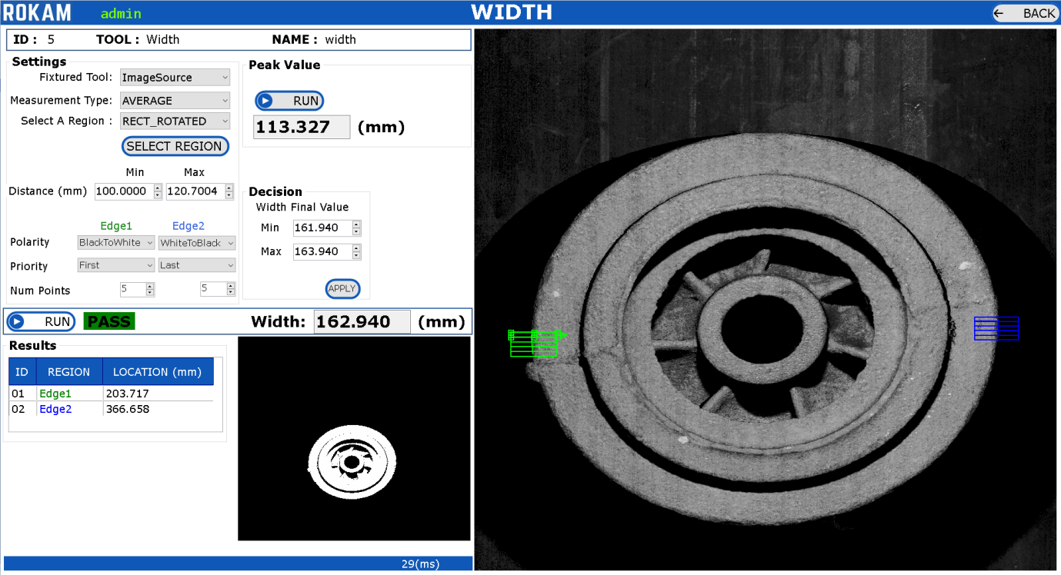

* Click on  Button. Modify the Regions.
* Enter the Width Min and Max Values.
* Click on  Button to get the Results.
* View the Results – Width in mm.
* Click on  Button to go back to Dashboard.

**Fixtured Tool**: Select ‘ImageSource’ or ’01-reference’ based on requirements.

ImageSource : Load actual image which is captured from camera.

01-reference : Load referenced image which is routed through pattern match max tool. If the Object is moved, then this tool also will move accordingly(x, y, angle).

**Measurement Type**:Select ‘AVERAGE’ or ‘HIGHEST’ or ‘LOWEST’ based on type of measurement.

**Select A Region**: Select the Region as RECT_ROTATED.

**Select Region Button**: Click on this button to add the new Region on the image and modify the region where we need to measure the width.

The Green-Color Region and Blue-Color Region used to calculate the width between two regions.

**Distance (mm)**: Enter the Min Max distance in mm where the width has to be identified.

**Polarity, Priority, Num Points:** Select the values for the Edge1 and Edge2, where the edge location has to be identified.

**Result**: The Result will be PASS or FAIL based on conditions, i.e., Width Min and Max. The Results contains the details such as Width in mm.

The Settings depends on type of application on how width tool has to be calculated.

**PIXEL COUNTER**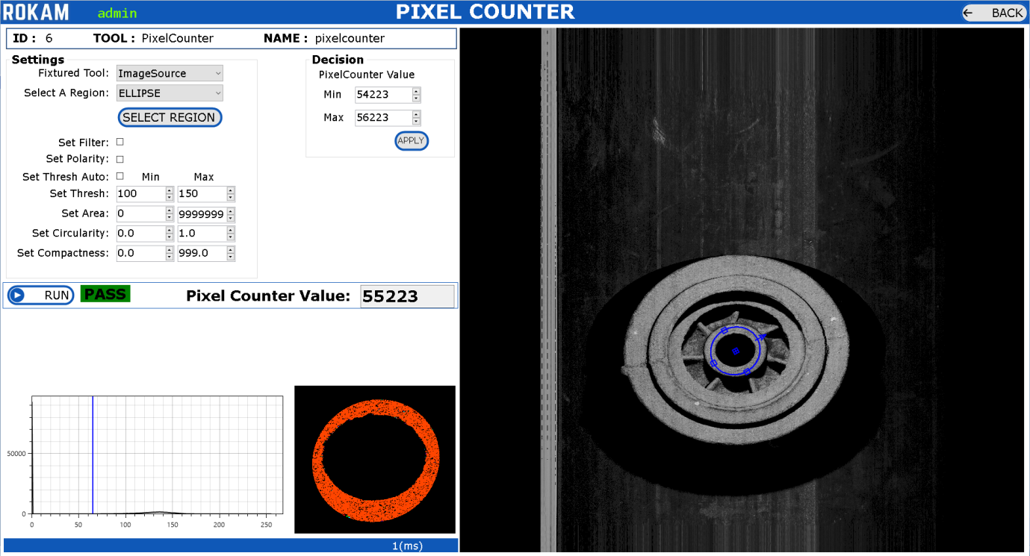

* Click on  Button. Modify the Regions.
* Enter the Set Thresh Min and Max Values.
* Click on  Button to get the Results.
* View the Results – Pixel Counter Value.
* Click on  Button to go back to Dashboard.

**Fixtured Tool**: Select ‘ImageSource’ or ’01-reference’ based on requirements.

ImageSource : Load actual image which is captured from camera.

01-reference : Load referenced image which is routed through pattern match max tool. If the Object is moved, then this tool also will move accordingly(x, y, angle).

**Select A Region**: Select the Region as RECT_ROTATED or ELLIPSE.

**Select Region Button**: Click on this button to add the new Region on the image and modify the region where we need to measure the summation of pixel gray values count in region.

**Set Thresh**: Enter the Min Max gray scale values in where the pixel counter values has to be taken into consideration for calculating pixel counter.

**Set Filter, Set Polarity, Set Area, Circularity, Compactness:** Select the Min and Max Values where the region has to be filtered.

**Result**: The Result will be PASS or FAIL based on conditions, i.e., PixelCounter Value Min and Max. The Results contains the details such as Summation of all Pixel Gray Scale values which are in the range of Thresh Min and Max.

The Settings depends on type of application on how width tool has to be calculated.

**COMBINE RESULTS**

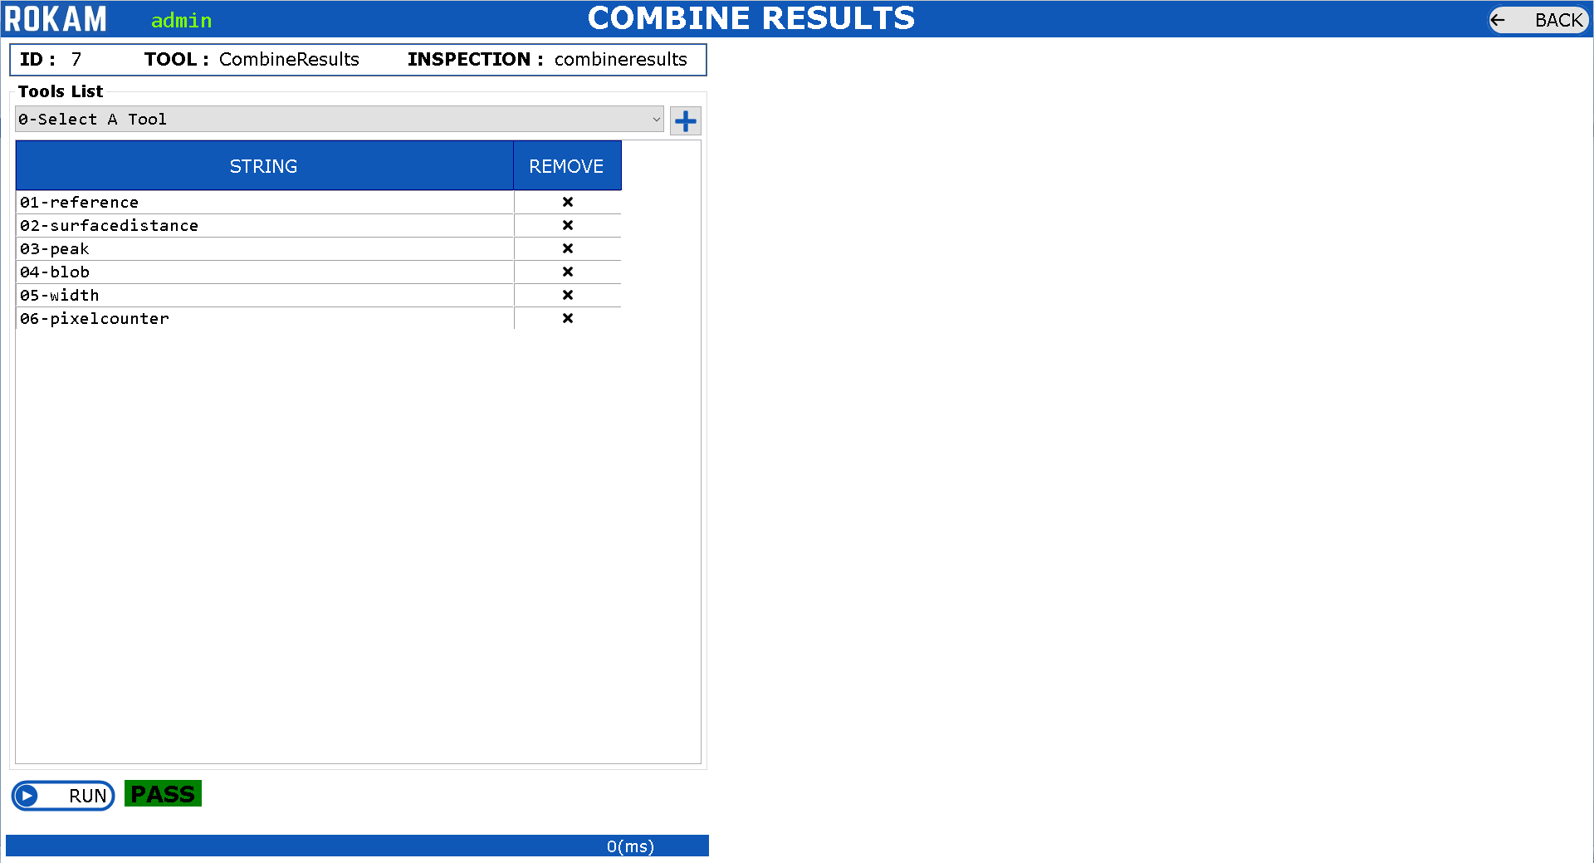

* Select the Tool from the List.
* Click on Button to add the Tool to List.
* Click on  Button to get the Results.
* View the Results – PASS or FAIL.
* Click on  Button to go back to Dashboard.

**Select A Tool**: Add/Delete the Configured Tools for Inspection which has to give combined results.

**Result**: The Result will be PASS or FAIL based on conditions, i.e., if any one of the tool is failed, then the final result will be FAIL or the final result will be PASS.

The Settings depends on type of application on how width tool has to be calculated.

## 2.10) COMMUNICATIONS

Accessible for: Administrator

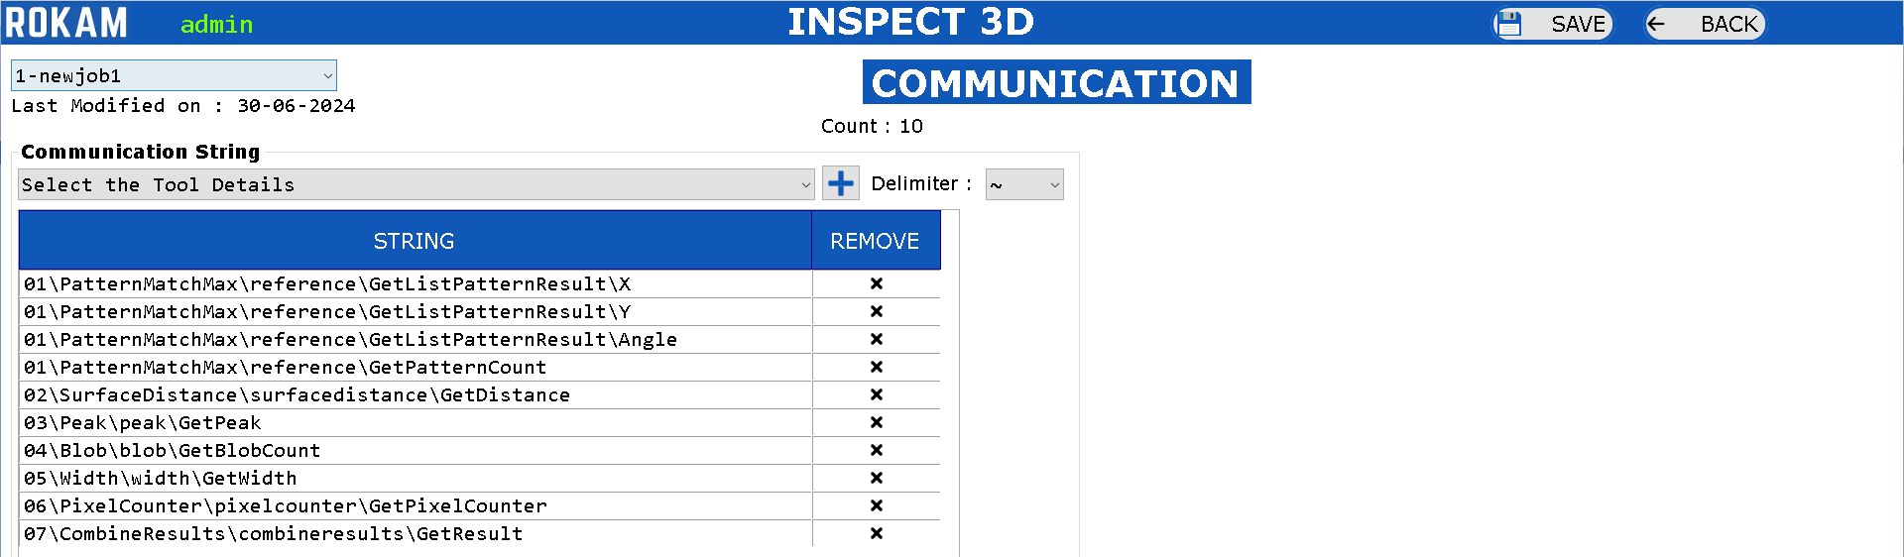

* Select the SKU Number. 
* Select the Communication String from the Tool using Drop-Down Box.
* Click on Button to add the String to the Communication List.
* Select the Delimiter from the Drop-Down Box.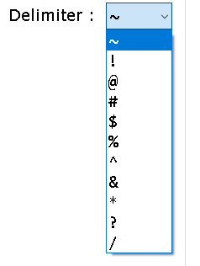
* Click on Button to Save the Communication String relevant to SKU.
* Click on  Button to go back to Dashboard.

For All Inspection Tools, all the result details will be available in this communication string to configure.

The configured communication string will be separated using “delimiter” when the communication string is sent through the TCP Server.

The configured communication string will be sent through the ModbusTCP to the respective modbus registers.

## 2.11) INSPECTION

Accessible for: Administrator, Maintenance, Operator

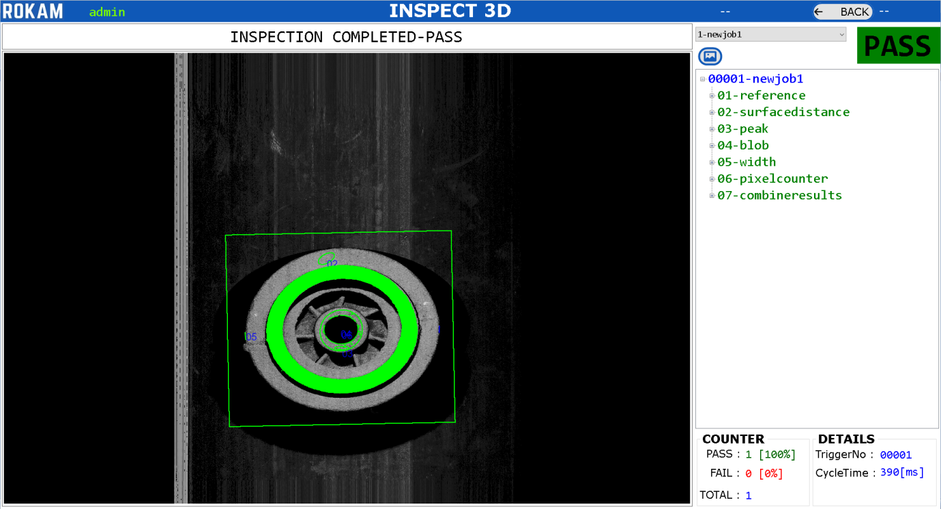

* Select the SKU Number. 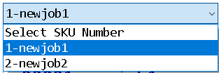 manually or wait for the PLC to automatically select the SKU Number through ModbusTCP Communication.
* The Settings which are linked with the respective SKU will be loaded to the Application.
* Administrator/Maintenance: Will have an option to manually load the image to inspect the image.
* Operator: Will have to wait for the PLC trigger to the camera through ModbusTCP.
* Once the Image is ready the inspection will happen automatically and update the following:
  + New Image with graphics will be updated to the Center of the Screen.
  + The Inspection Results for all Tools are updated to Tree view on the Right side of the Screen.
  + The Counter will be updated with the PASS/FAIL Counter at the Bottom Right of the Screen.
  + The Details will be updated with the Trigger Number and Cycle Time at the Bottom Right of the Screen.
  + The Message to the Operator on the status of the application is updated in the Top Center of the Screen.

## 2.12) ALARMS

Accessible for: Administrator, Maintenance, Operator

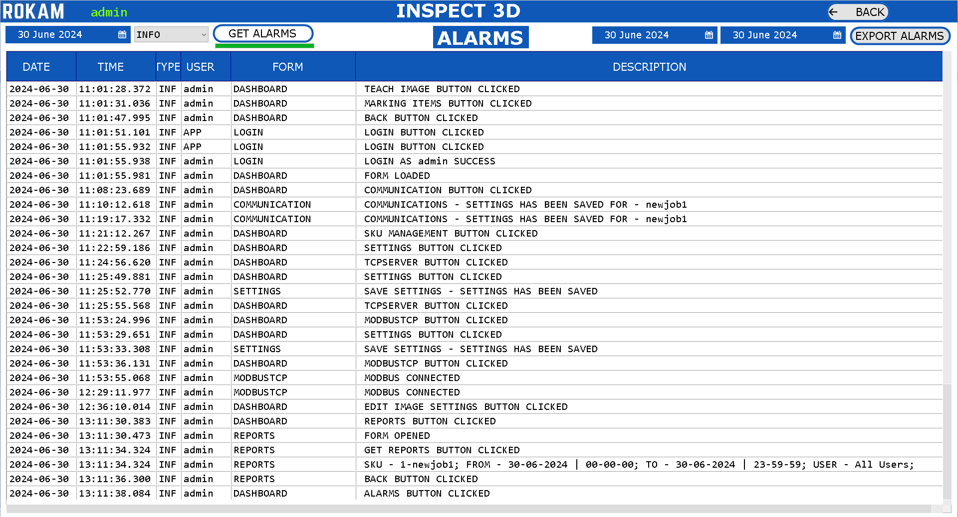

Alarms will show all log information of the application.

* Select Date . Select Type of Alarm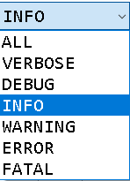
* Click on  Button.
* To Export the Alarms, Click on Start Date and End Date and Click on “Export Alarms” Button. This alarms data will be exported to the “Data Location” Folder.
* Click on  Button to back to Dashboard.

## 2.13) RESULTS

Accessible for: Administrator, Maintenance, Operator

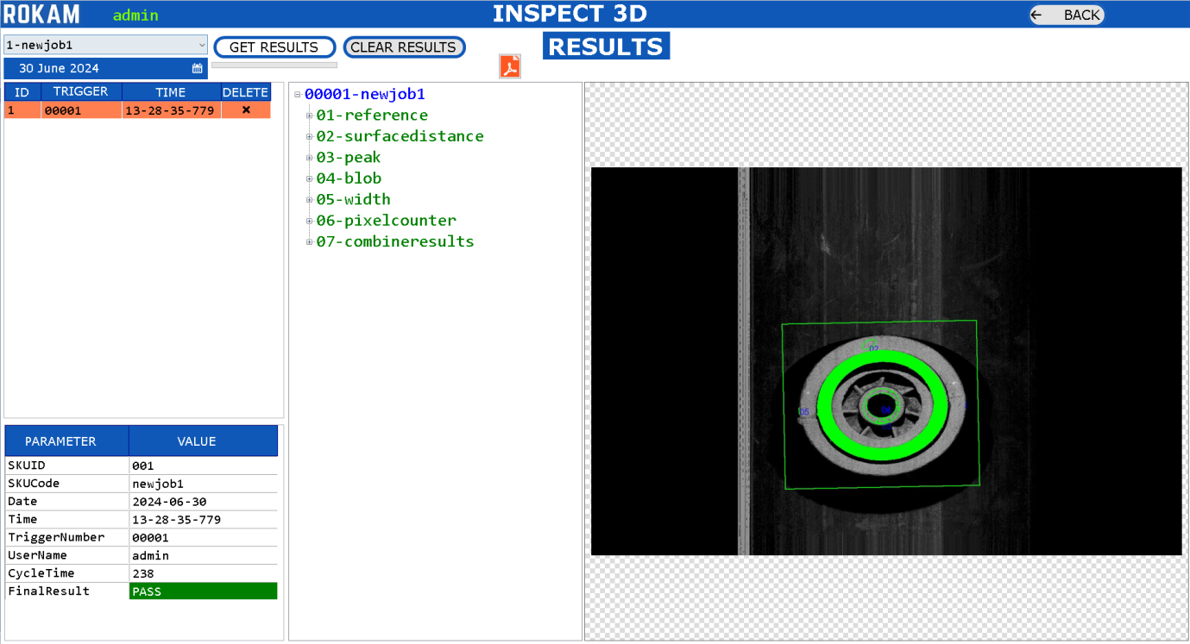

* Select the SKU Number. 
* Select the Date. 
* Click on Button.
* The Results will be Displayed in the List
* Click on the Trigger Number to see the Result of the inspected object.
* Click on to see the PDF report of the Inspection.
* Expand the Tree View to View the Full Inspection details of the inspected object.
* The Graphics Image will be updated in the Center of the Screen.
* The Metadata Information about the inspected object is available in the Bottom Left-Side of the Screen.
* Click on  Button to go back to Dashboard.

## 2.14) REPORTS

Accessible for: Administrator, Maintenance, Operator

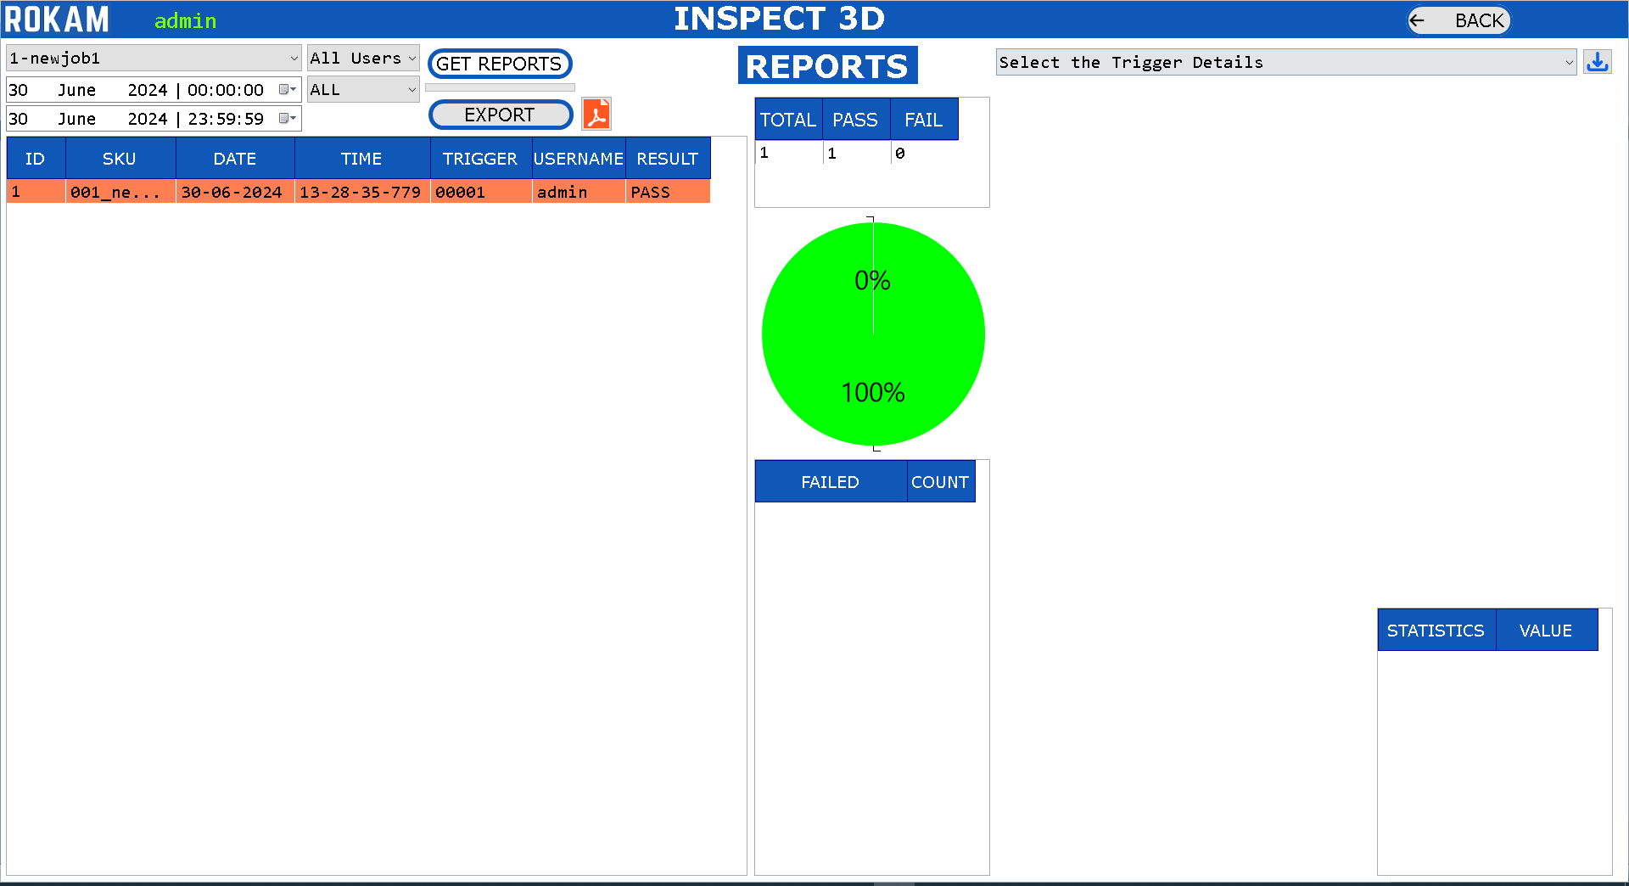

* Select the SKU Number. 
* Select the Start Date and End Date.
* Select the User Name
* Select the Result PASS/FAIL/ALL.
* Click on  Button.
* The Total/Pass/Fail will be shown in Table and also in Pie Chart.
* The Failed Details will be shown in Table.
* The Results of all Inspection Details will be updated to the List.
* Click on  Button to export the list of all inspection Details to the CSV File to the Data Location Folder.
* Click on the Trigger Number to see the Result of the inspected object.
* Click on to see the PDF report of the Inspection.
* Click on  Button to go back to Dashboard.
* Select the Trigger Details to see the history of all inspection results in the form of graph.

## 2.15) TCP SERVER

Accessible for: Administrator and Maintenance

When we select TCP Server Option, then Application will act as TCP Server and the PLC should act as TCP Client.

Following are TCP Server Commands used to control application in Inspection Screen:

(1) **Reset the Job**

Syntax: SKU_RESET

Response: SUCCESS or FAILURE

(2) **Get the List of Jobs Available**

Syntax: SKU_LIST

Response: Provides the List of Jobs with comma separated

(3) **Select the Job – 3 Ways to Load Job**

Syntax: SKUCODE_jobName

Example: SKUCODE_newjob1

Response: SUCCESS or FAILURE

Syntax: SKUID_jobID

Example: SKU_001

Response: SUCCESS or FAILURE

Syntax: SKUIDCODE _jobID-jobName

Example: SKU_001-newjob1

Response: SUCCESS or FAILURE

Action: The Application will load the respective SKU Settings to the inspection.

(4) **Trigger Image**

Syntax: TRIGGER_filename

Example: TRIGGER_range-image_00001

Response: Data which is configured in Communications

(5) **Trigger Camera**

Syntax: TRIGGER

Response: Data which is configured in Communications

To simulate TCP Client, we use Hercules Application which can be downloaded from internet.

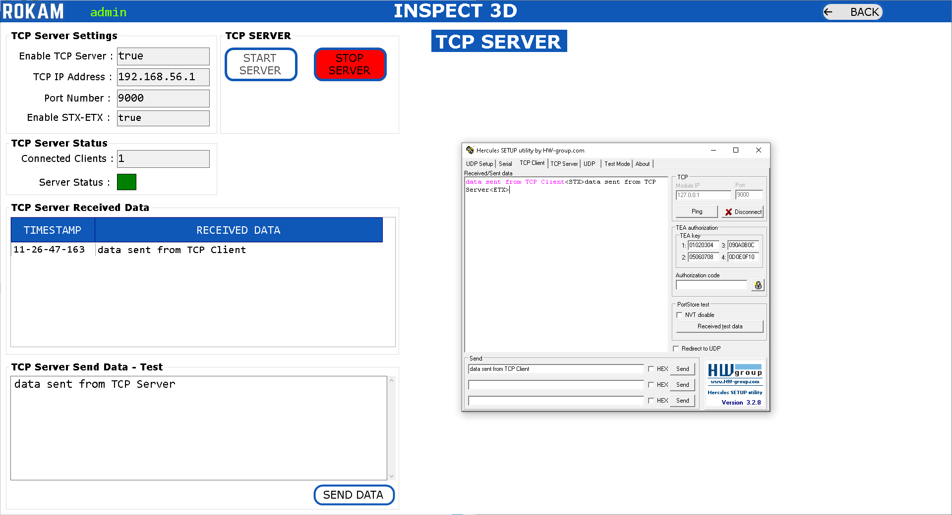

* Click on START SERVER button.
* Open Hercules Application and Open TCP Client. Enter the IP Address as “127.0.0.1” or the IP Address which is visible in the TCP Server Screen.
* Enter Port Number which is configured in the TCP Server in the TCP Client.
* Click on Connect Button in the TCP Client.
* Send some data from TCP Client and check if the data is received in TCP Server.
* Send some data from TCP Server and check if the data is received in TCP Client.
* If the Data sending and receiving is occurring fine between TCP Client and TCP Server, then we can confirm that the TCP Server is working fine as expected.
* Click on STOP SERVER button.
* Click on button to go back to Dashboard.

## 2.16) MODBUS TCP

Accessible for: Administrator and Maintenance

When we select ModbusTCP Option, then Application will act as Modbus TCP Client and the PLC should act as Modbus TCP Server.

IP Address, Port Number, Start Address, and Multiplication Factor (for digital values): Will be configured in the Settings.

Heart-beat for the Inspect3D Application to monitor ModbusTCP Register to write/read is 30 milliseconds.

Handshaking of Registers between the PLC and ModbusTCP in the Inspect3D Application is explained below.

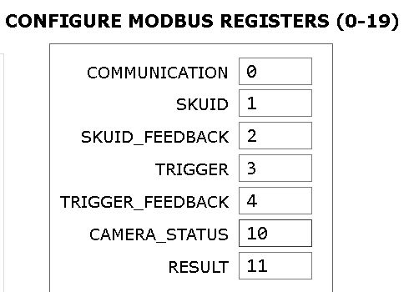

The Standard Modbus Registers are pre-configured with the Register Locations. It is possible to reconfigure the Register Locations. This is accessible only for Administrator.

**COMMUNICATION**: It is used to establish a hear-beat kind of communication between the Inspect3D Application and the PLC. For every 5 Seconds, the Application will write the register value as ‘1’ and the PLC will check if the value is ‘1’ or not. If the value is not ‘1’ within the heart-beat time, then PLC can know that there is some problem with communication. PLC also will write the register value as ‘2’.

**SKUID:** When we need to select an SKU from the PLC, then PLC will write to SKUID Register location with a number (SKUID). Please refer SKU Management to get to know the SKUID of each SKU.

**SKUID_FEEDBACK:** The Application will monitor the SKUID and if the Valid SKUID is read in the SKUID Register location, then the respective SKU will be loaded to the application (all the camera and inspection parameters are loaded and ready to inspect). Once the SKU is successfully loaded, then the SKUID_FEEDBACK register will be written with the same ‘SKUID Value’ by the Application. Once the PLC will read the same value in the register, then PLC will reset this register to ‘0’.

*Example* : PLC will send the value as ‘5’ to the SKUID register, then Application will look for the load the SKUID which is ‘5’. Upon successful loading of SKU, then Value ‘5’ will be sent back to the SKUID_FEEDBACK Register Location.

**TRIGGER:** When we need to start the inspection for an object, then PLC will write to TRIGGER Register location with a number ‘1’.

**TRIGGER_FEEDBACK**: Once the Application read this register TRIGGER with value ‘1’, then the TRIGGER Register will be reset with number ‘0’ and TRIGGER_FEEDBACK will be written as ‘1’. The PLC will receive the TRIGGER_FEEDBACK and reset the Value with ‘0’.

**CAMERA_STATUS**: The CAMERA_STATUS Register value will be written by the Application. The PLC will monitor this camera status and perform the process steps as per their automation cycle.

Register Value as 3 => if the inspection is in progress.

Register Value as 2 => ready to take the trigger

Register Value as 0 => camera is not yet ready

**RESULT**: The RESULT Register value will be written by the Application. The PLC will monitor this result and perform the process steps as per their automation cycle.

Register Value as 2 => if the Result is FAIL.

Register Value as 1 => if the Result is PASS.

Register Value as 0 => if the Result is Not Yet Ready.

**Location of MODBUS Registers**:

Register Location: Start Address [Refer Settings] + Register Location

|  |  |
| --- | --- |
| **REGISTER NAME** | **REGISTER LOCATION** |
| COMMUNICATION | 0(configurable between 0-19) |
| SKUID | 1(configurable between 0-19) |
| SKUID_FEEDBACK | 2(configurable between 0-19) |
| TRIGGER | 3(configurable between 0-19) |
| TRIGGER_FEEDBACK | 4(configurable between 0-19) |
| CAMERA_STATUS | 10(configurable between 0-19) |
| RESULT | 11(configurable between 0-19) |

|  |  |
| --- | --- |
| **CUSTOM-REGISTER NAME** | **REGISTER LOCATION** |
| String1 Configured in Communication | 20 |
| String2 Configured in Communication | 21 |
| String3 Configured in Communication | 22 |
| String4 Configured in Communication | 23 |
| String5 Configured in Communication | 24 |
| String6Configured in Communication | 25 |
| ... | .. |
| … | .. |

To simulate Modbus TCP, we use Modbus Simulator Application which can be downloaded from internet.

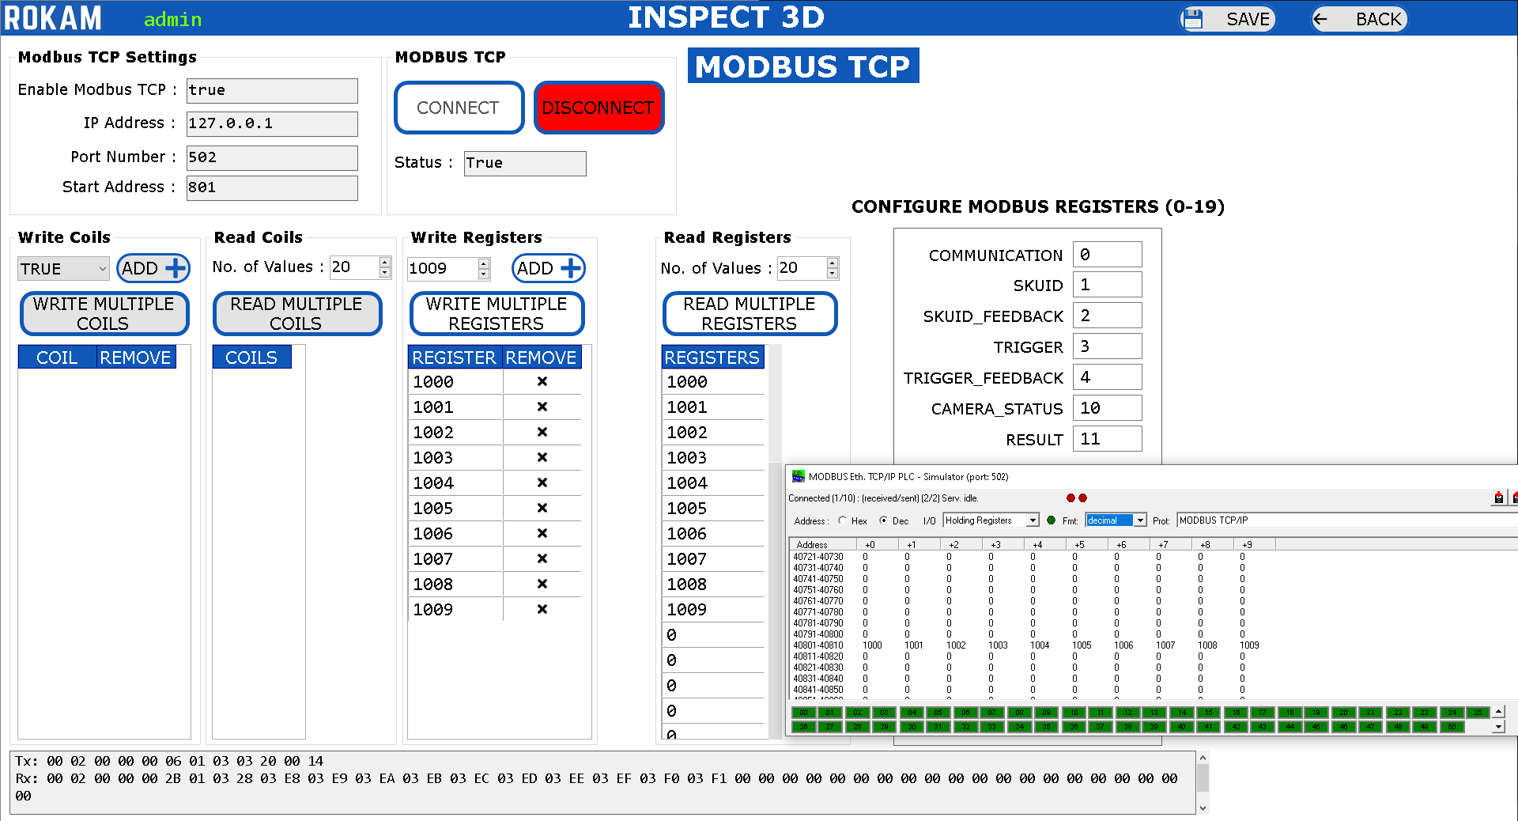

* Open Modbus Server in the PLC.
* Click on CONNECT button. If the Modbus in the PLC is opened, then the Modbus TCP Client Application will Connect otherwise it will NOT Connect.
* Write Registers: Select the Value and Click on ADD Button.
* Write Registers: Click on WRITE MULTIPLE REGISTERS Button.
* Read Registers: Click on READ MULTIPLE REGISTERS Button.
* The Values which are written should be able to read.
* Click on DISCONNECT button.
* Click on button to go back to Dashboard.

## 2.17) EDIT IMAGE SETTINGS

Accessible for: Administrator and Maintenance

## 

* Select the SKU Number. 
* Click on Button.
* Click to edit the “MIN VALUE NEW” and “MAX VALUE NEW” for each inspection tool name. These Values will decide for PASS or FAIL for the Inspection Result for individual tool.
* View the “MIN VALUE OLD” and “MAX VALUE OLD” to view existing settings value.
* Click on  button to save the Image Settings.
* Click on  button to go back to Dashboard.

# MAINTENANCE

* The Inspection Results are stored in the “Data Location” Folder. Please make sure that there is minimum of 25% of the Free Space available always in that respective drive.
* If there is the less than 5% of the Free Space available in the Application Installation Drive(C Drive ideally) or in the “Data Location” Folder Drive, then the application will not open.

# TROUBLESHOOTING

* There are 3 kinds of Messages which will appear through Dialog Box.
* Information, Warning, Error
* When an Error occurs delete the SKU in which we are getting error through SKU Management and create a new SKU for the same.
* Please read the camera user manual instructions carefully for the troubleshooting.